PRIMARY SCHOOL - MUSIC JOURNEY
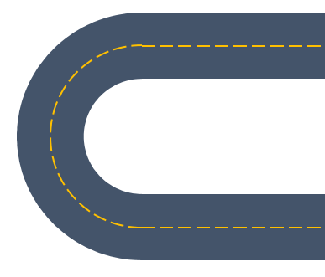
Autumn
Listening and voice development.
Listening and voice development, Christmas performance.

Spring 1:
Music notation and ukuleles
- Learning to read notation from the book Rainbow ukulele
Summer 2:
Final performance project.
- Putting together a showcase for the end of the year

Summer 1:
Exploring dynamics and rhythm through composing, performing, singing, and improvising.

Spring 2:
Composing to a stimulus using different elements in small groups
Spring 1:
Exploring pitch and rhythm through composing, performing, singing, and improvising.

Spring
Pitch and Tempo developing singing skills.
Listening and thinking, playing and timbre.

Summer
Develop thinking voice and composition.
Pulse, rhythm, dynamics using percussion instruments.

Autumn 1:
Performing pentatonic melodies from basic notation

Autumn 2:
Exploring tempo through composing, performing, singing, and improvising.

AUTUMN 1:
Exploring pulse and rhythm through composing, performing, singing, and improvising.

Spring 2:
Composing with different forms and scales
- Composing with music technology
Autumn 2:
Composing and improvising with the pentatonic scale

Summer 2:
Final performance project.
- Putting together a showcase for the end of the year

Summer 1:
‘Happy!’
- Learning how to perform in a band
Spring 1
Three Little Birds
- Performing a song with the recorder and singing
Summer 1
The Beatles and Blackbird
- Performing a song with the recorder and singing

Summer 2
Final performance project
- Putting together a showcase for the end of the year
Spring 2
Classroom Jazz
- Performing jazz music on the recorder
Autumn 2
Composing and improvising with the recorder
- Using Charanga to support composing and performing with the recorder.

Autumn 1
Introduction to the recorder
- Learning basic recorder technique

Key Stage 1

Lower Key Stage 2

Upper Key Stage 2

Music Journey
EYFS

