PRIMARY SCHOOL - HISTORY JOURNEY
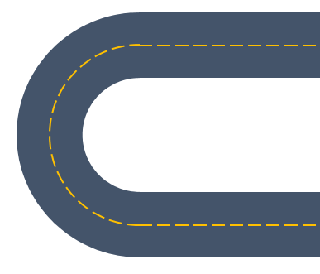
Autumn 1:
Early Islamic Civilisation
Early Islamic Civilisation - Baghdad

Spring 2:
Florence Nightingale

Autumn 2:
The Gunpowder Plot
Industrial Revolution

Autumn 1:
Queen Victoria
Queen Elizabeth II

Spring 1:
The Plague
Great Fire of London

Summer 1:
Neil Armstrong
The Moon Landing

Summer 2:
First World War
Invention of Radio

Spring 2:
The Victoria Era – Innovation and Industry

Autumn 2:
Ancient Greeks
Ancient Greeks – Influence and Impact

Spring 1:
The Victoria Era

Summer 2:
The Second World War
The Second World War - Impact
Summer 1:
The Tudors
The Tudors – Tudor Monarchs
Spring 1:

Romans Around the World
Summer 1:

Anglo Saxons Kingdoms and Conquests
Viking Kingdoms and Conquests

Summer 2:
Egyptian Pyramids and Obelisks
Egyptian Beliefs and Burials
Spring 2:
Roman Britain
Autumn 2:

Bronze Age Around the World

Autumn 1:
Iron Age
Iron Age and Weapons

Key Stage 1

Lower Key Stage 2

Upper Key Stage 2

History Journey
Autumn
Talk about members of their immediate family and community

Spring
Comment on images of familiar situations in the past.

Summer
Compare and contrast characters from stories, including figures from the past.

EYFS

