Teams – How to Login
NB: The following screenshots have been taken on a PC. The instructions are the same for tablet devices.
On any web browser, e.g. Google Chrome, Internet Explorer, Safari etc, go to www.office.com

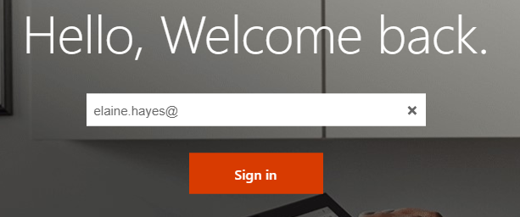
Click sign in and sign in with your full school email address.
Your child’s address is:

Their password has been set to:

Click on the Teams icon
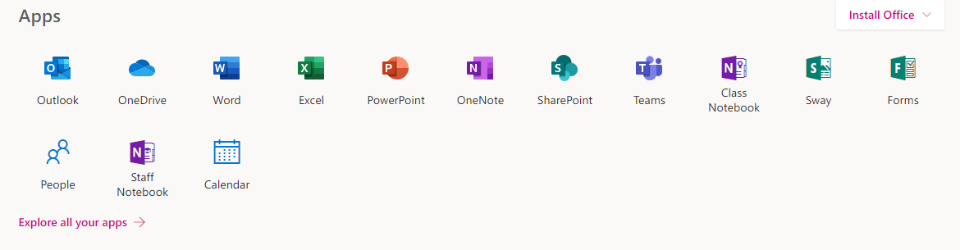

You should now see your year group team.

Teams – Accessing and uploading learning
Your teacher can set assignment for you to complete. You can access this in two different ways. You can click the assignments button in the left-hand menu to see all the different assignments set by your teacher, or you can click into your class and click on the assignments button circled in yellow.
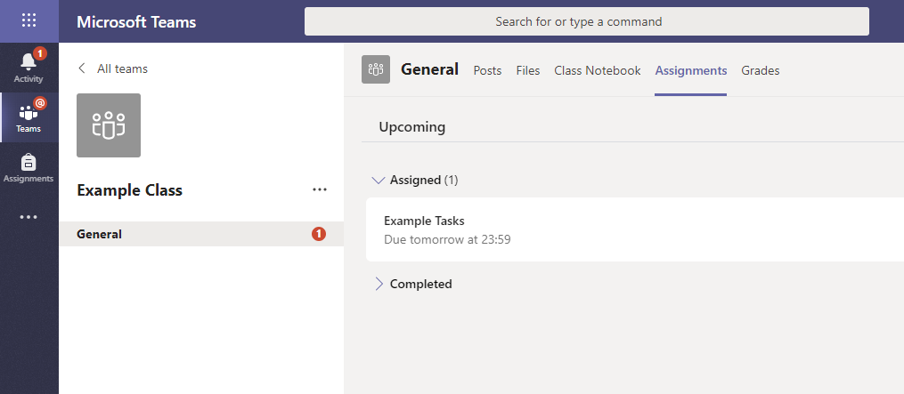

Click on the assignment to access the task.
To add your work, click on the add work. You can add a document that you have already been working on, or create a new one that you can do your work on. Your teacher will have given you some instructions on how to submit your work.
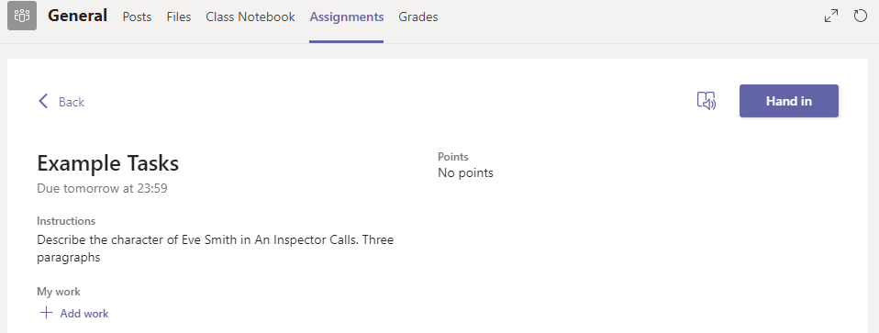
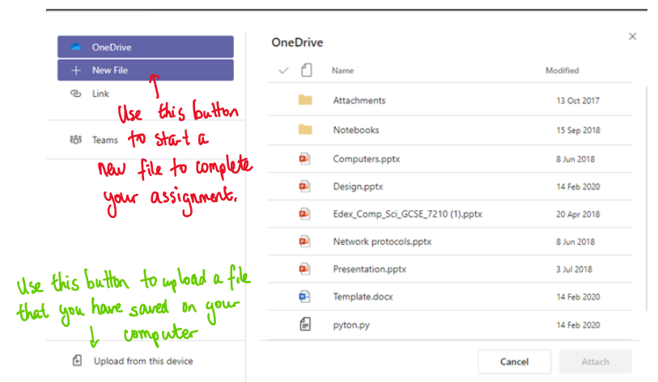
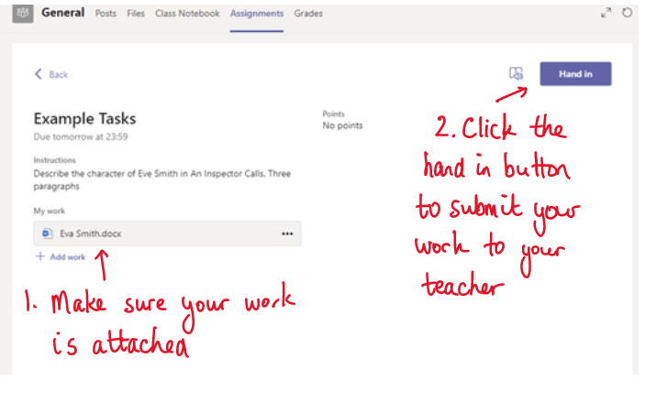
Make sure that you have your work attached. Click the hand in button. Your teacher can now look at your work and give you feedback if required.

