PRIMARY SCHOOL - DT JOURNEY
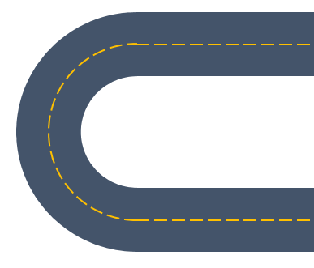
Summer 2:
Portable Snacks
Couscous

Summer 1:

Spring 2:
Slider mechanisms

Fixed Wheels and Axels

Spring 1:

Spring

Summer

Autumn 1:

Autumn 2:
What is Design and Technology
Structures
Frame Structures

AUTUMN 1:

Spring 2:
Food through the year - bread

Autumn 2:
What is DT
Frame Structures

Spring 1:
Art Structures
Food through the Years

Summer 2:
Pulleys – cable car
Summer 1:
Electronic motors
Spring 1

Summer 1
Dips

Summer 2
Shell Structures

Spring 2
Paper Circuits

Autumn 2
Pneumatics

Autumn 1

Key Stage 1

Lower Key Stage 2

Upper Key Stage 2

Dsiegn/Technology Journey
Autumn

EYFS

