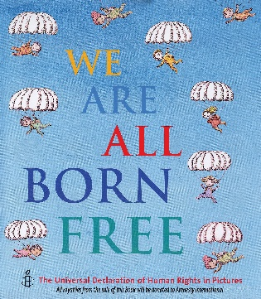
ABOUT AMNESTY INTERNATIONAL -
They are a global movement of ordinary people standing up for humanity and human rights. Their purpose is to protect individuals wherever justice, fairness, freedom and truth are denied.
Many of you have seen the book ‘We are all Born Free’ published by Amnesty International.
Below are the Children’s Rights Statements for you to cut up. Choose one and write the statement at the top of your piece of paper and illustrate it underneath as in the picture below. The idea is that we

You don’t have to use paper; you could show the rights in other ways too.
Be Creative - paint on tiles; sculpt little clay or plaster figures for each right; make a collage of fabrics or embroidered squares.

