Dear parents and carers,

It’s been another busy week at school and the classes are well and truly settled into their routines and learning. We have seen everything from place value in maths to letter writing; from counting to writing wanted posters and of course making Christmas Cards! As per usual, your child has had the opportunity to design a Christmas Card that you will be able to buy. Please watch out for a letter with more information towards half term. This is a PTFA activity and does raise money for some of those amazing extras that they fund us for.

Year 5 have also been busy undertaking their Bikeability course this week. The rain didn’t hinder them heading out on to the roads and I would like to thank their parents for their support in getting a change of clothes, or waterproofs, into school. Year 6 will be doing the course next and we shall rebook the team to come back in again this time next year for the future Year 5 to have this opportunity.

If you have come into the foyer over the last week, you may have noticed that we have a new sculpture just inside the internal doors. I am thrilled that The Grove Comm-oo-nity Cow has arrived and my thanks go to Lion Yard for purchasing the cow for us. We are considering where she should live on a permanent basis on our school premises.

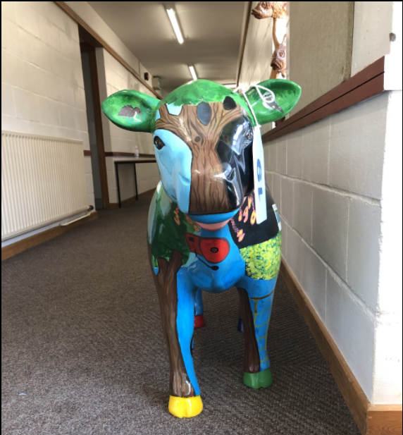

Stay safe,

Miss Shaw



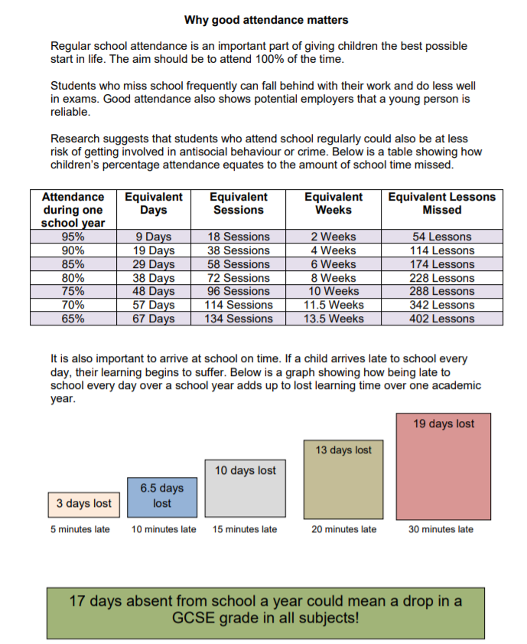

**Free Football Sessions**

In order to participate in sessions, you MUST REGISTER using this link:

[https://forms.gle/sE4JhQaT1rtAGBkW9](https://forms.gle/sE4JhQaT1rtAGBkW9?fbclid=IwAR0H7WXOZc9voNle_BMG0OU91h7Urwf-fI332CQSvZTHd4Is41CkM4VMAgs)



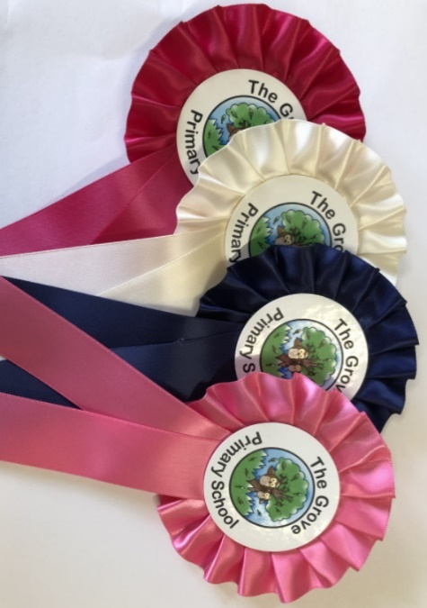

**Rosettes at achievement assembly were presented to:**

**Friday 17th September 2021**

**Toucan: Zari, Kyra**

**Hummingbird: Simon, Kacey**

**Woodpecker: Musa, Sai**

**Flamingo: Mustafa, Donny**

**Kookaburra: Lia, Daniel**

**Ostrich: Layla, Maya**

**Wren: Anakae, Gabriel**

**Gosling: Leela, Kendra**

**The Aviary: Finley, Robynn**