**\*Buying a Balloon** - Lola bought a balloon at the circus. She gave the clown six coins to pay for it. What could Lola have paid for the balloon? Have you found all the possible solutions?



Which of your answers seems a reasonable amount to pay for a balloon?

**\*\* Maze 100 -** In this maze there are numbers in each of the cells. You go through adding all the numbers that you pass. You may not go through any cell more than once. Can you find a way through in which the numbers add to exactly 100?

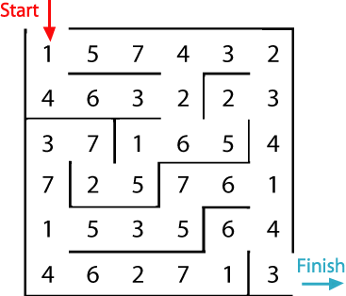  
What is the lowest number you can make going through the maze? What is the highest number you can make going through the maze? (Remember you may not go through any cell more than once.)

# 

**\*\*\*4 Dom -** Use these four dominoes to make a square that has the same number of dots on each side.

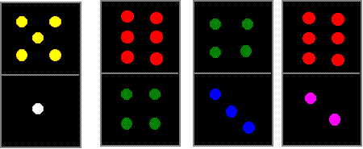 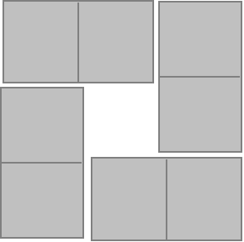

We would love to see pictures of your completed square; please also tell us what you do to try and solve the challenge.

# **\*\*Twenty Divided Into Six**

Katie had a pack of twenty cards numbered from 1 to 20. She arranged the cards into six piles. The numbers on the cards in each pile added to the same total.

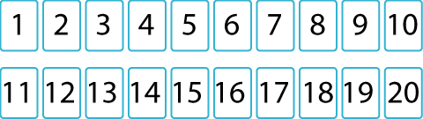

What was the total of each pile?

**Challenge** - Find as many completely different solutions to this problem as possible. Can you suggest a way to find them all?