My Book About Me.

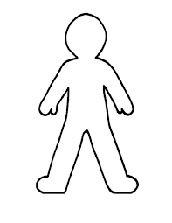

My name is

I am _______________ years old.

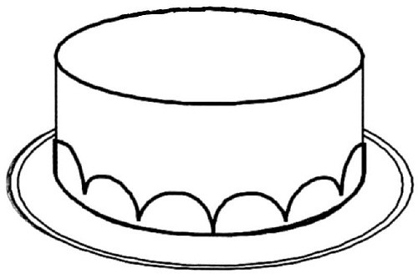

Can you draw the same amount of candles on the birthday cake and colour it in?

This is my family.

This is my home.

When I am at home I like to.....

My favourite toy is.....

My favourite character on TV is.....

__________________________________

These are foods I like to eat.

I can.....
Put my socks and shoes on.
Wipe my nose & wash my hands.
Tidy up my toys.
Hold a pencil properly.
Wash my hands with soap.
Get dressed and undressed.
Use buttons and zips.
Go to the toilet and flush.
Follow instructions

Open my lunch box.
Use a knife and fork.
Colour in the balloons to tell us what you can do without a grown up to help you.

