Dear parents and carers,

With just over three weeks to go, there is a definite sense of "so much to do and so little time left".  Year 5 and 6 are busy practising their end of term production, ‘Mystery at Magpie Manor’.  The singing sounds amazing and I am very much looking forward to seeing the end result.  Tickets are now on sale via Pay360 and we have asked for a minimum donation of £1 per ticket.  This goes towards the cost of buying the scripts and the performance license fee.

You may be aware that the NEU are calling a further two strike days on Wednesday 5th and Friday 7th July.  I have asked teachers if they would be prepared to let me know their intention again and I will notify you by the end of next week of any potential closures.  Staff do not have to tell me until the morning of the strike day so I appreciate that they do give me notice.

Our sporting competitions are now in full swing.  Thursday night saw our Y4 football team in action. For their first outing as a school team, they showed fantastic skill and resilience. Well done to everyone involved!

Next week is going to be busy!  On Tuesday, our Year 5 and 6 pupils will be joining in a singing workshop with the NCA staff during the morning.  The staff are visiting us here and we look forward to welcoming them.  There is also a Y5/6 rounders competition on Wednesday morning as well.

On Thursday 29th June our coffee mornings make a long-awaited return.  ‘Coffee with Kindness’ will be held in our meeting room first thing.  Please come round to the front door and a member of the team will be there to greet you.  I am hoping this will be well attended.

Have a good weekend

Miss Shaw

**Attendance**

|  |  |
| --- | --- |
| **Class Name** | **% attendance from Monday 19th June to Friday 23rd June** |
| **The Aviary** | 67% |
| **Gosling** | 84% |
| **Wren** | 98% |
| **Flamingo** | 96% |
| **Ostrich** | 97% |
| **Kookaburra** | 97% |
| **Kingfisher** | 94% |
| **Toucan** | 88% |
| **Hummingbird** | 90% |
| **Whole School** | 92% |

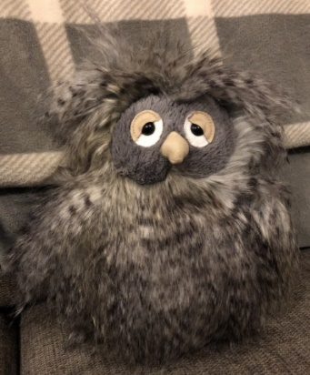

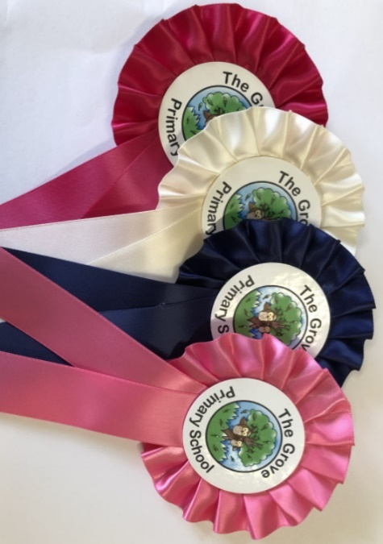

**Rosettes at achievement assembly have been presented to:**

**Friday 23rd June**

**Hummingbird: Jordan, Fraser, Kyra**

**Toucan: Ellie W, Ozodbek**

**Kingfisher: Alisha, Calan**

**Kookaburra: Bella, Harshan**

**Ostrich: Izzy, Alessandro**

**Flamingo: George, Jake**

**Wren: Michael, Dylan D**

**Gosling: AnnaMaria, Zeifa**

**Nursery Mieskzo**