The Grove Primary School

English and Phonics Curriculum Statement

English is at the heart of our curriculum at The Grove. Through the teaching of high-quality texts, our children learn to both express themselves and better understand the world around them. We use The Literacy Tree as our Scheme of Work and this details the progression across our school from Reception.
Writing
We read high-quality texts to inspire and engage children in the writing process. These texts are from a variety of different genres and are diverse in their viewpoints and authorship, providing a model for our children to aspire to.
Children at The Grove learn how to become confident and articulate writers across a range of text types through a carefully-sequenced learning journey where they are given numerous opportunities to:
- see and hear the writing process modelled by their teacher (“shared writing”)
- gather and learn new vocabulary
- practise and build up a bank of literary phrases for effect
- discuss their ideas before starting to write
- edit their own work both independently and in response to teacher feedback
Key to our children’s enthusiasm for writing is that teachers always make writing opportunities purposeful, with real audiences and reasons why the children need to express themselves.
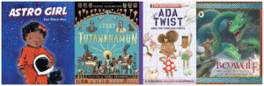
Reading
At The Grove, we believe that all pupils should enjoy and develop a love of reading. We strive to expose our children to a wide range of beautifully written, high-quality texts which demonstrate aspirational language, reflect our school community and underpin the The Grove school values.
Being able to read unlocks the curriculum for our children; it allows them to access word problems in Maths and Science, read and understand sources of information in History and above all sparks their imagination, enriches their writing and encourages a range of creative skills.
We aim to cultivate readers with a passion for a wide range of genres to ensure that their love of reading extends beyond the classroom and evokes a thirst for knowledge and a curiosity for life.
Children at The Grove are exposed to a varied diet of Reading. Reading weaves its way through the curriculum, the classroom environment and the wider culture of the school.
Children are exposed to reading through:
- ‘Teaching of Reading’ whole class lessons in Years 2-6. In EYFS and Y1, children have small group (Daily Supported Reading) and 1:1 reading sessions
- Reading opportunities across the curriculum
- Classroom Book Corners
- Story time
- Opportunities for independent reading
- Reading at home
- Visits to the school library
- Special reading weeks
- Local library trips
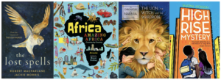
Phonics
Our aim at The Grove is to foster a love of reading and writing in our children.
Phonics is a system by which children learn to read and write. Children learn individual sounds (phonemes) and their corresponding letters (graphemes) which they either blend together to read or they segment (break down words into sounds) to write.
We use Little Wandle’s Letters and Sounds programme to teach phonics. Phonics is taught daily in Early Years and KS1 with reference still being made to it as a reading and writing strategy in KS2. Common exception words, sometimes called tricky words, are also taught. These are words such as ‘the’ and ‘said’ which cannot be read phonetically, so they are learnt by sight. Children are given books to take home with the phonemes that they have been taught at school, making them more confident in their reading.
Little Wandle’s Letters and Sounds is split into 6 phases with each phase building in complexity. Phase 1 is taught in nursery, phase 2, 3 and 4 in Reception, phase 5 in Year 1 and phase 6 in Year 2. There can be overlap in which years phases are taught.
We take pride in delivering engaging and inclusive phonics lessons, giving all children the opportunity to get ahead at their own pace.

Phonics
At The Grove we use Little Wandle Letters and Sounds Revised 2021 to deliver phonics and early reading.
This programme overview shows the progression of GPCs and tricky words that we teach term-by-term. The progression has been organised so that children are taught from the simple to more complex GPCs, as well as taking into account the frequency of their occurrence in the most commonly encountered words. All the graphemes taught are practised in words, sentences, and later on, in fully decodable books. Children review and revise GPCs and words, daily, weekly and across terms and years, in order to move this knowledge into their long term memory.
Children need to learn to read as quickly as reasonably possible, so they can move from learning to read, to reading to learn, giving them access to the treasure house of reading. Our expectations of progression are aspirational yet achievable if schools maintain pace, practice and participation by all children. Children who are not keeping-up with their peers should be given additional practice immediately through keep-up sessions.

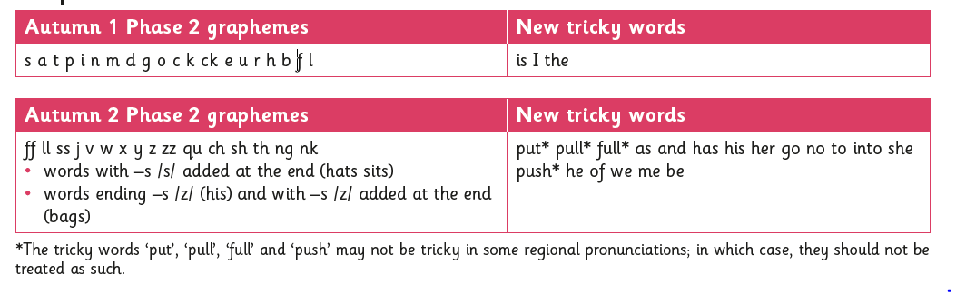
Reception
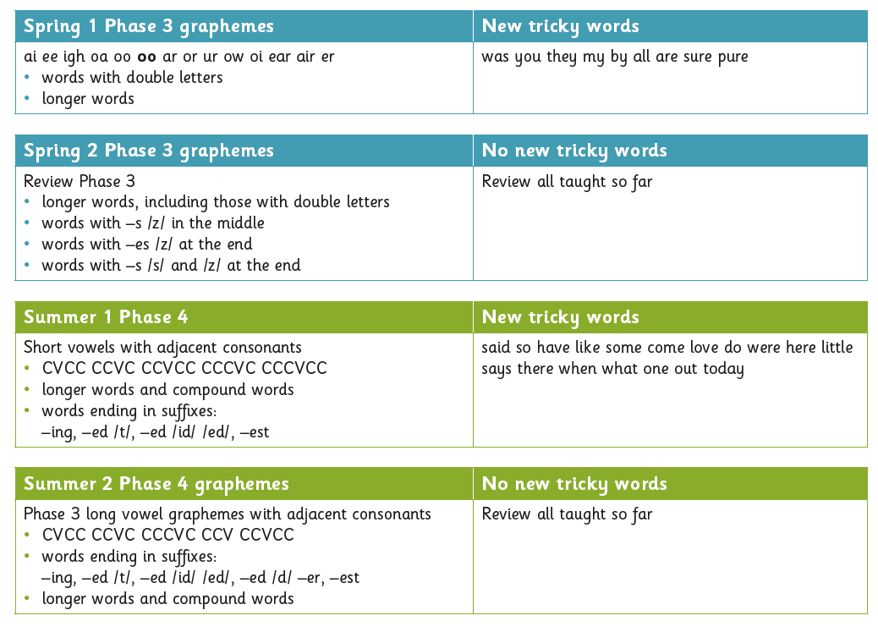
Year 1 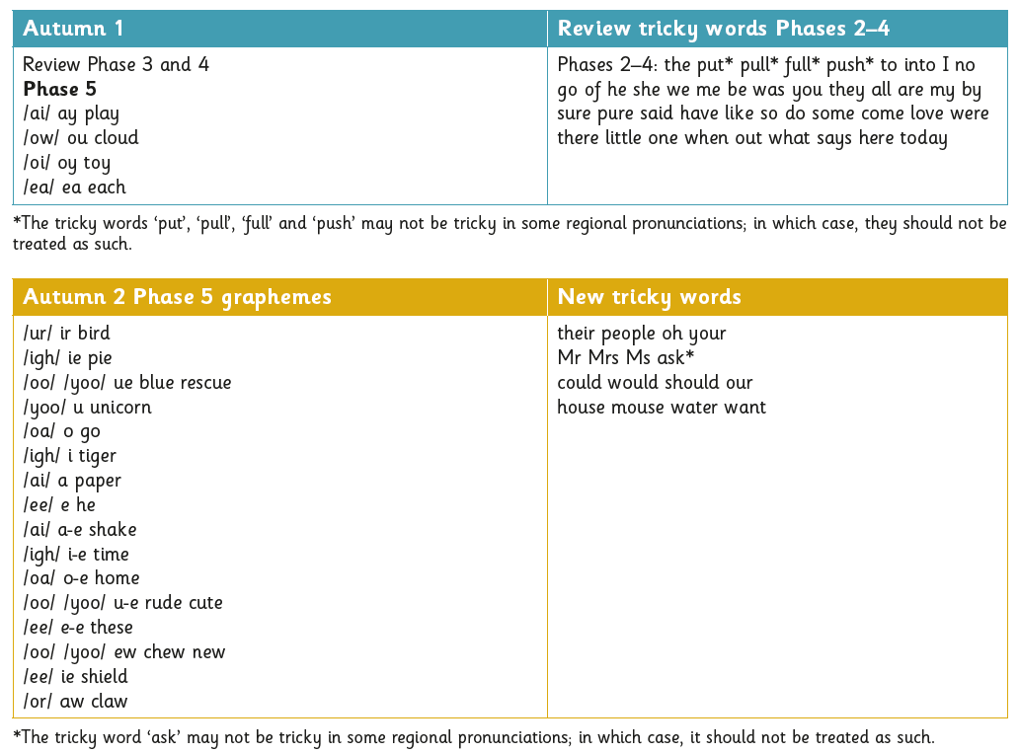
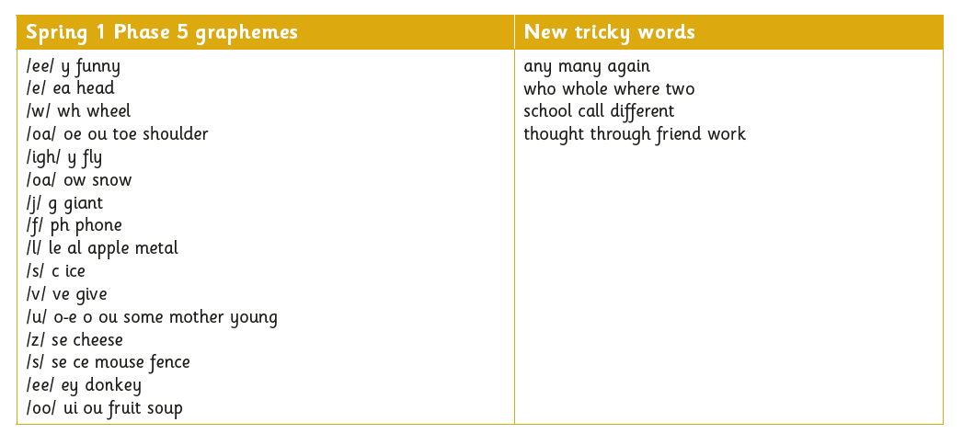
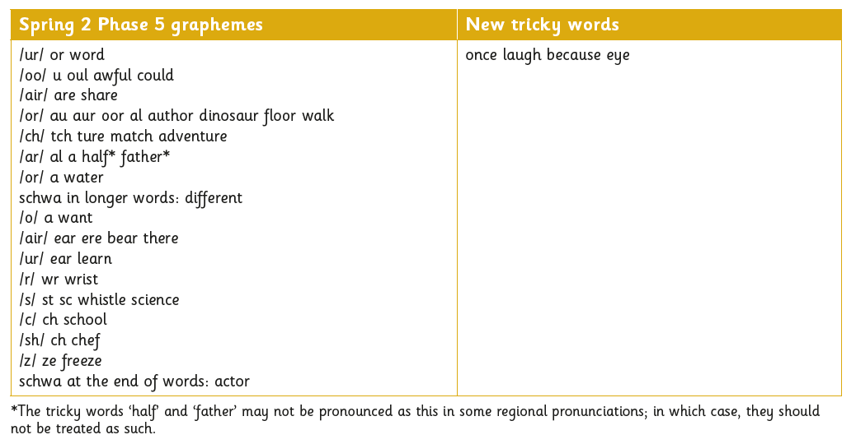
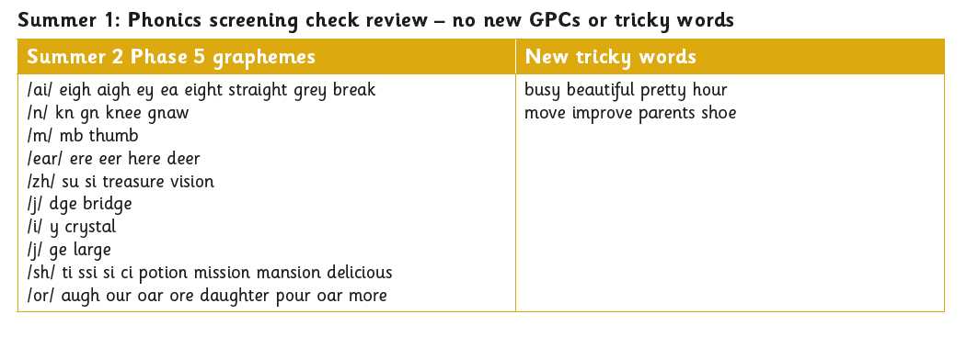
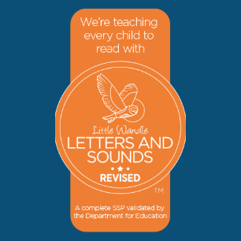
To support your child’s phonics through games we recommend the following websites:
Phonics Play
Little Wandle Letters and Sounds

Writing
Writing at key stages 1 and 2 consists of two dimensions:
- transcription (spelling and handwriting)
- composition (articulating ideas and structuring them in speech and writing).
Writing down ideas fluently depends on effective transcription: that is, on spelling quickly and accurately through knowing the relationship between sounds and letters (phonics) and understanding the morphology (word structure) and orthography (spelling structure) of words. Effective composition involves forming, articulating and communicating ideas, and then organising them coherently for a reader. This requires clarity, awareness of the audience, purpose and context, and an increasingly wide knowledge of vocabulary and grammar. Writing also depends on fluent, legible and, eventually, speedy handwriting. High expectations in handwriting are developed and maintained from EYFS upwards, with emphasis placed on correct letter and number formation being developed and maintained in all writing.
Lessons are taught through the use of high quality core texts, which are linked to the curriculum topic. The teaching sequence begins with the immersion of the children within the text through the use of an engaging starting point, drama, speaking and listening activities, and gathering initial ideas. Grammar objectives are then taught and developed in the context of the text with the children then applying these skills by writing a variety of different text types. This includes through teacher modelling, supported and shared writing, and task-led independent writing. Children are given regular opportunities to write for different purposes and audiences across the curriculum, as well as developing their ability to write at length.
Spelling, vocabulary, grammar, punctuation and glossary
Opportunities to enhance pupils’ vocabulary arise naturally from their reading and writing. As vocabulary increases, pupils will learn to understand the relationships between words, how to understand nuances in meaning, and how to develop their understanding of, and ability to use, figurative language. Pupils will also learn how to work out and clarify the meanings of unknown words and words with more than one meaning.

Language
Pupils should be able to do the following by the time they leave Year 6:
- listen and respond appropriately to adults and their peers
- ask relevant questions to extend their understanding and knowledge
- use relevant strategies to build their vocabulary
- articulate and justify answers, arguments and opinions
- give well-structured descriptions, explanations and narratives for different purposes, including for expressing feelings
- maintain attention and participate actively in collaborative conversations, staying on topic and initiating and responding to comments
- use spoken language to develop understanding through speculating, hypothesising, imagining and exploring ideas
- speak audibly and fluently with an increasing command of Standard English
- participate in discussions, presentations, performances, role play, improvisations and debates
- gain, maintain and monitor the interest of the listener(s)
- consider and evaluate different viewpoints, attending to and building on the contributions of others
Spoken language is therefore covered daily across the entire school curriculum here at The Grove.
Reading at key stages 1 and 2 consist of two dimensions:
- word reading
- comprehension (both listening and reading).
Skilled word reading involves both the speedy working out of the pronunciation of unfamiliar printed words (decoding) and the speedy recognition of familiar printed words. Underpinning both is the understanding that the letters on the page represent the sounds in spoken words. This is why phonics is emphasised in the early teaching of reading.
Good comprehension draws from linguistic knowledge (in particular of vocabulary and grammar) and on knowledge of the world. Comprehension skills develop through pupils’ experience of high-quality discussion with the teacher, as well as from reading and discussing a range of stories, poems and non-fiction. All pupils are encouraged to read widely across both fiction and non-fiction to develop their knowledge of themselves and the world in which they live, to establish an appreciation and love of reading, and to gain knowledge across the curriculum. Reading widely and often increases pupils’ vocabulary because they encounter words they would rarely hear or use in everyday speech. Reading also feeds pupils’ imagination and opens up a treasure-house of wonder and joy for curious young minds.
Reading is taught initially through shared stories (EYFS) leading to more formal ‘Daily Supported Reading’ in Reception and Year 1. This is a reading programme that ensures all children have daily opportunities to read independently, in small groups, at their ability level with a trained adult. This continues into early Year 2 alongside whole class reading sessions. In Key Stage 2 these whole class reading sessions continue with a focus on key strategies for comprehending messages and accessing information.

Reading at The Grove School
At The Grove school we take a great pride in our children’s attitude to and love of reading. Events such as Book Week have paved the way for a real enthusiasm in developing the essential skill of reading. Learning to read the words on a page is just one small part of developing a lifelong enjoyment of reading and an ability to use reading to discover new things. Our aim at The Grove School is to help children become independent readers who enjoy reading and learn from it.
Taking a book to read at home is just one part of our children’s reading diet. At The Grove School children enjoy reading books they have chosen quietly in our class reading corners, in the library, with a peer or supporting a younger child as a reading buddy. They enjoy reading a range of different texts with staff during a wide variety of lessons to support their learning. They also read individually with a teacher or teaching assistant.
Each child’s reading diet is specifically tailored to their individual interests and need. We use the Collins Big Cat scheme which offer a wide choice of new texts which include traditional tales, classics, a range of up to date and relevant non-fiction texts, poetry and even graphic novels.
At school, children develop a range of reading skills throughout the curriculum including whole class sessions, one to one reading and reading independently. Staff and volunteers regularly record information about the reading your child has done at school in their reading record. This will be in the form of a comment or a sticker. Below is some information about the ways in which we teach children to read at school.
Whole class teaching – Whole class teaching happens throughout the day. Children are exposed to a wide range of texts in Literacy and across all areas of the curriculum, both fiction and non-fiction. They use their reading skills to find and interoperate information across a wide range of subjects. Specific reading objectives are targeted through exercises such as ‘Text Talk’, Independent Reading, Reading a class text and Comprehension Skills. These objectives are varied as required depending on the needs of the individual children.
Reading with a teacher – All children can expect to have a small group reading session regularly with a teacher. During these reading sessions the teacher will target specific children to read with the aim of focusing on a specific objective as well as discussing the text and supporting the child’s enthusiasm and engagement in a wide range of texts in order to support the development of positive attitudes to reading and understanding of what they read.
Reading with a TA – All children will have the opportunity to read with a TA regularly. Some children will, based on specific needs, be daily or weekly readers with a TA. TAs will focus on specific objective as well as discussing the text and supporting the child’s enthusiasm and engagement in a wide range of texts in order to support the development of positive attitudes to reading and understanding of what they read.
Reading with a buddy – Some children from UKS2 have weekly reading sessions with a Buddy in EYFS and KS1. The Buddy’s focus with be discussing the text and supporting the child’s and engagement in a wide range of texts in order to support the development of positive attitudes to reading and understanding of what they read.

