THE GROVE PRIMARY SCHOOL - GEOGRAPHY JOURNEY
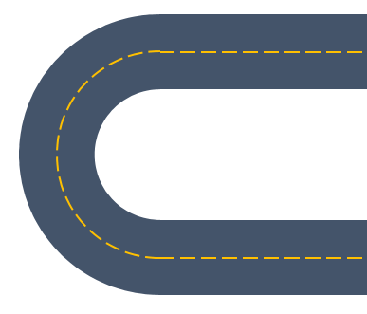
SPRING 1

n/a

SPRING 2

a) The Pacific Ocean
b) The Arctic Ocean

AUTUMN 2

Weather

AUTUMN 1

Mapping the World

SPRING

Continents and Oceans

SUMMER 1

a) The United Kingdom
b) Australia

SUMMER 2
a) The United Kingdom: England
b) England: London
SPRING 2

Biomes and Climate Zones cont:
- Freshwater Biome
- Savannah Biome

AUTUMN 2

a) Using map features
b) Using maps: 4 and 6 figure grid references

AUTUMN 1

n/a
SUMMER 2
North and South America - Mountains, Rivers and population

SUMMER 1

n/a

SPRING 1

Earthquakes and Volcanoes: Plate Tectonics / The Pacific Ring of Fire / Impact

SUMMER 1

Climate Change

SUMMER 2

n/a
SPRING 2

Erosion and Deposition – Coasts / Management
AUTUMN 2

International Trade: Food / Natural Resources

AUTUMN 1

a) Maps of the World
b) International transport and International Trade: Tourism

Key Stage 1

Lower Key Stage 2

Upper Key Stage 2

Geography Journey
AUTUMN
a) Explore and identify features in the school / local environment.

b) Devise simple maps

SPRING
Name and describe people who are familiar to them – discuss people they may have come across within the community e.g. shop staff, hairdressers etc.

SUMMER

n/a

EYFS

