PRIMARY SCHOOL - SCIENCE JOURNEY
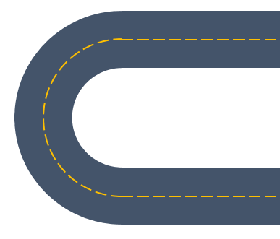
Spring 2:
Evolution and Inheritance - How animals and plants are adapted to suit their environment
Light and Electricity – Explain how light sources travel to the eye

Summer 2:
Living Things - Describe the life process of reproduction in some plants and animals
Forces and magnets – Poles, attracting and repelling and how unsupported objects fall
Summer 1:
Animals and Humans –Circulatory system and the importance of a healthy body
Sound – Patterns between volume and vibration
Autumn 1:
States of Matter – Compare and group together everyday materials based on evidence from comparative and fair tests
Summer 2:
Living things – Investigate differences
Forces – Describe basic movement
Earth and Space – Observe seasonal changes

Summer 1:
Habitats – Look at the suitability of environments and at food chains
Animals and humans – Identify, classify and observe; growth basic needs, exercise, food and hygiene

Spring 2:
Plants – Observe and describe growth and conditions for growth
Earth and Space – Observe seasonal changes
Sound – Look at sources

Spring 1:
Earth and Space – Observe seasonal changes
Materials – Identify, name, describe, classify and compare properties and changes

Materials – Look at the practical uses of everyday materials

Spring
Different categories of animals, Nocturnal animals, Seasonal Changes – growth and change over time.
Growing seeds – what do plants need? Investigating plants in school grounds/local area, Seasonal Changes

Summer
Lifecycle of a frog (link to pond dipping), Habitats – minibeasts, Continuing to look after plants.
Light - exploring sources, Shadow play

Autumn 2:
Light – look at sources and reflections
Electricity – look at appliances and circuits

AUTUMN 1:
Plants – Identify, classify and describe their basic structure
Earth and Space – Seasonal change

Autumn 2:
Plants –
Describe how plants and animals may evolve through adaptation to their environment

Spring 1:
Earth and Space –
Use the idea of the Earth’s rotation to explain day and night and the apparent movement of the Sun across the sky

Spring 1
Evolution and Inheritance

Summer 1
Animals and Humans

Summer 2
Plants
Light

Spring 2
Materials

Autumn 2
States of Matter

Autumn 1
Plants and Sound

Key Stage 1

Lower Key Stage 2

Upper Key Stage 2

Science Journey
Autumn
Parts of our body (including teeth), Senses, Seasonal Changes
Floating/sinking , Magnets, Taking care of our planet

EYFS

